1.

centroids table:K = 10

[45, 33, 6]

[224, 226, 210]

[217, 61, 10]

[107, 95, 27]

[92, 43, 10]

[206, 187, 149]

[15, 8, 2]

[90, 131, 163]

[225, 184, 50]

[155, 135, 73]

2.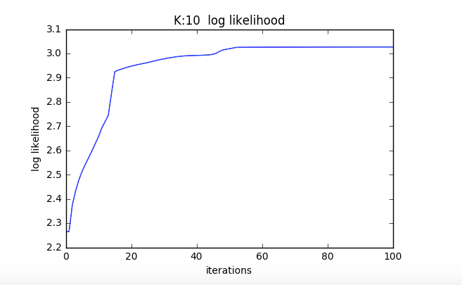

3.

centroids table: K = 2

[77, 46, 12]

[205, 184, 125]

centroids table: K = 3

[190, 135, 47]

[207, 201, 176]

[50, 34, 9]

centroids table: K = 5

[216, 178, 61]

[115, 105, 54]

[38, 23, 5]

[211, 204, 180]

[209, 58, 9]

centroids table: K = 20

[214, 171, 74]

[236, 206, 38]

[22, 12, 1]

[91, 78, 20]

[141, 34, 7]

[86, 131, 172]

[190, 60, 14]

[55, 43, 9]

[226, 230, 215]

[209, 181, 132]

[227, 123, 59]

[123, 109, 25]

[38, 27, 4]

[230, 61, 6]

[206, 196, 171]

[102, 97, 75]

[181, 158, 36]

[5, 3, 2]

[88, 37, 5]

[152, 136, 88]

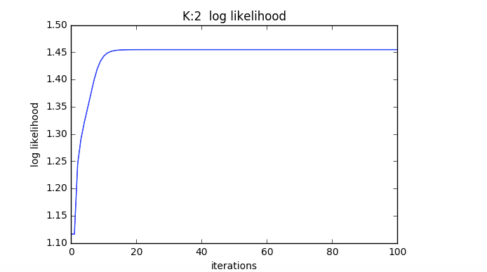

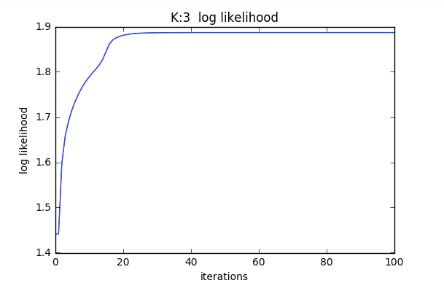

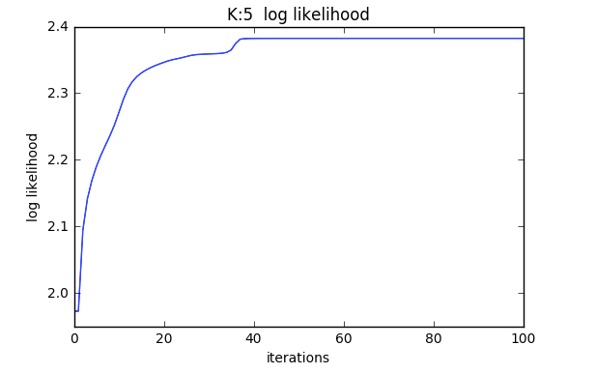

K=20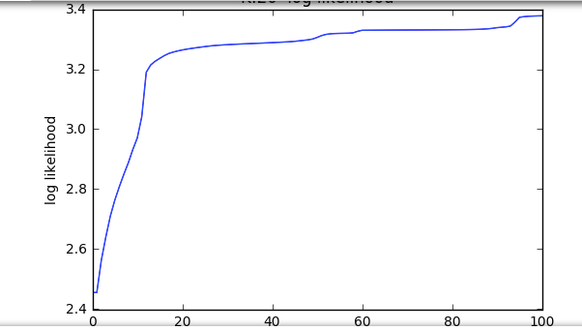

Kmeans

K = 2 K = 3

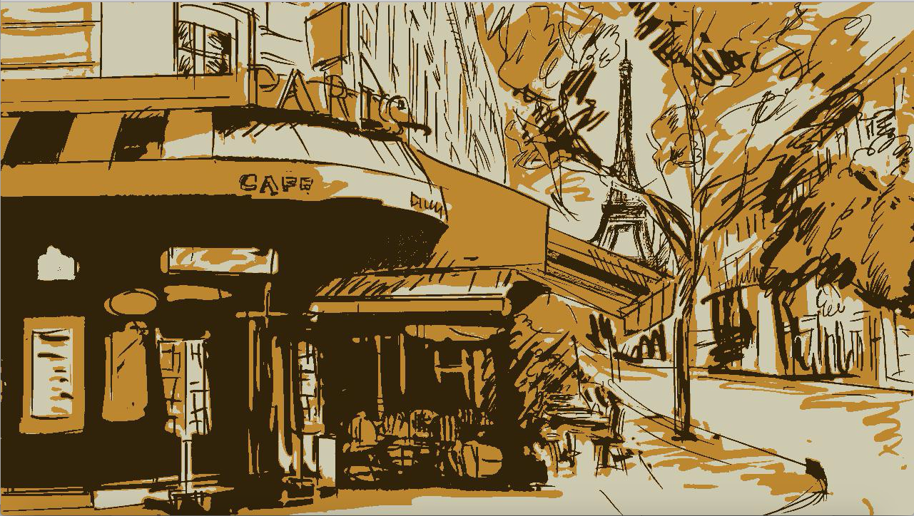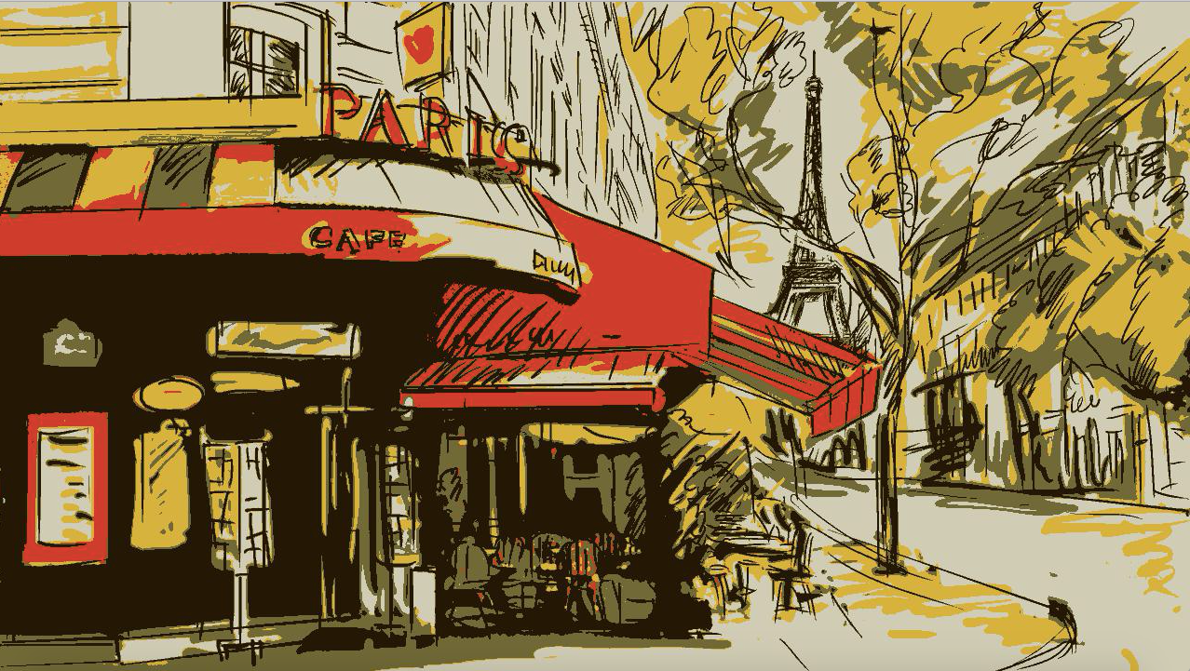

K = 5 K = 20



K = 10 Original

EM

EM_K = 2 EM_K = 3

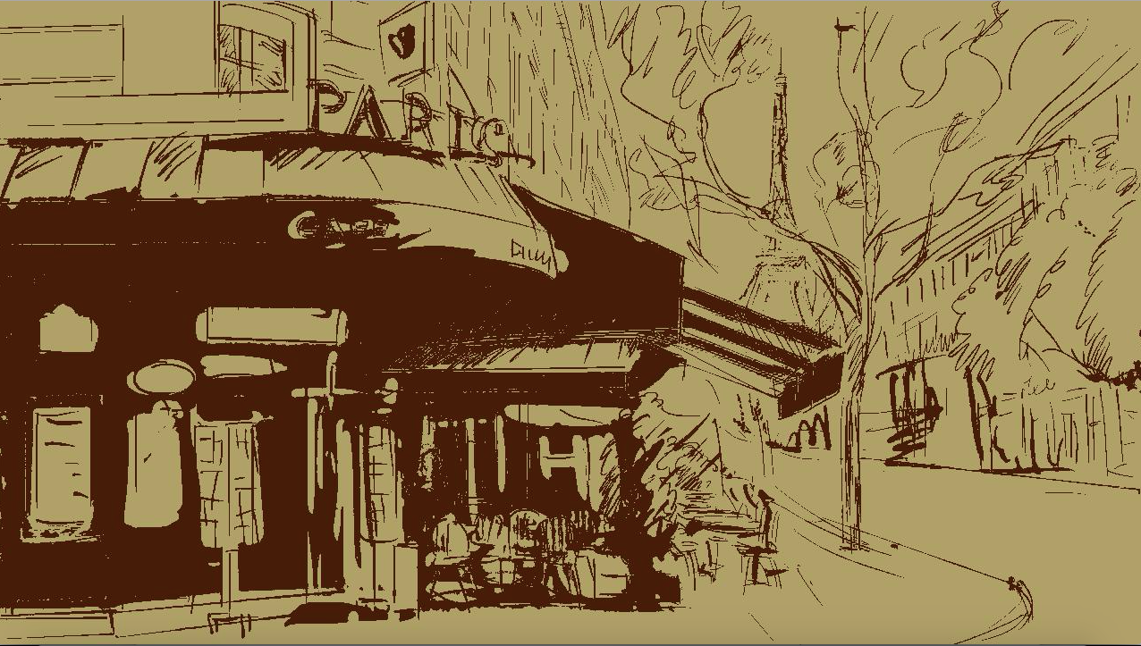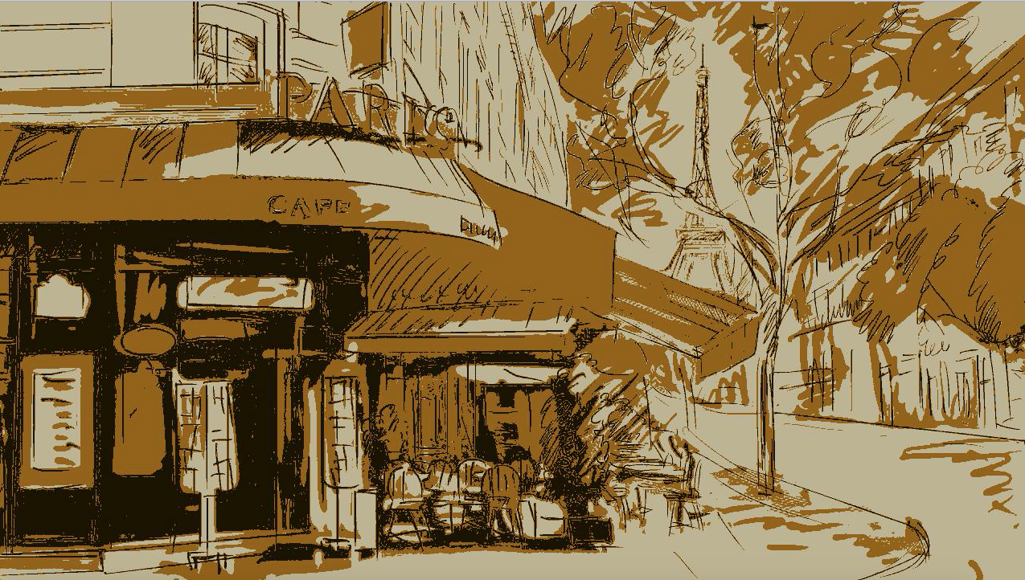

EM_K = 5 EM_K = 20



EM_K = 10 Original

Kmeans is colorful than EM.

About EM:

From the loglikelihood, we can infer bigger K will get higher likelihood at the beginning, but getting slower convergence for EM, because EM can let loglikelihood get higher when K is bigger.